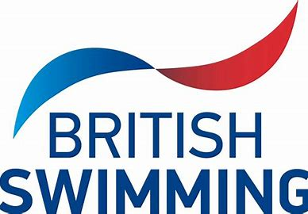
Officials information
What is an official?
Essentially, we are the people in white on the poolside at galas. We are all are volunteers (most of us are parents of swimmers), and our role is to ensure galas are run fairly so all swimmers have an equal chance to compete and achieve their best.
To be an official you do not need to be a swimmer yourself or even know the rules beforehand as this will be covered in the training and a period of mentoring is provided before qualifying. Once qualified you will be licensed by British Swimming and this will allow you to officiate at any level of competition. A licence is valid for 4 years after which it can be renewed.
If you wish to peruse training as an official, we will be very grateful and will fully support you in your development. The club will cover the cost of the courses and pay for both your Swim England and Club membership fees which are requirements for being on poolside.
Please do give consideration to whether this is something you would be interested in. We really do need more officials and it is one way as parents we can really support our children with their swimming. Galas and Championships cannot be run without officials. Without these events our children cannot compete, without competing they will never realise their full potential in their chosen sport.
There are 5 levels of qualification in total, each a progression from the last and there is no requirement at all to complete all levels.
Timekeeper (TK) – This is the introductory level and can be done on its own or as part of the Judge Level 1 qualification. It covers all aspects of time keeping and the training comprises of a short online course followed by a poolside sign off by a qualified referee. Please note this on its own does not give you a British Swimming Licence but does allow you to be a timekeeper at unlicenced events or level 4 galas such as our Club Champs.
Judge Level 1 (JL1) – This is the first licenced qualification and on completion of the e-learning there is a period of 15 hours of poolside mentoring where you will be supported in your development by an experienced official. This role covers timekeeper and the role of inspector of turns (IOT) which ensures the starts, turns and finishes are in accordance with the rules.
Judge Level 2 (JL2) – This role covers all aspects of swimming and builds on the training received at JL1. Currently the training is delivered by virtual, face to face sessions on either Teams or Zoom and like JL1 is followed by a period of poolside mentoring. JL2 can be started following JL1 once a prerequisite number of post qualification hours have been completed.
Starter (JL2s) – Essentially this gives the qualification to be the official starter at open meets and the training for this is much more in depth than anything previously. It follows on from the JL2, following completion of the JL2 qualification and a further prerequisite number of poolside being completed.
Referee (REF) – The highest level of qualification offered by British Swimming, awarded following a written examination in all aspects of swimming, a period of mentoring and poolside assessments. The referee is the senior official who holds the overall responsibility and accountability for the gala being run safely, fairly and in accordance with the rules set by Swim England and the World Aquatics.
If you would like any further information or just to have a chat, please seek me out on a training night or email:
Biggleswadesc.officials@gmail.com

